- Obtain sample of patients that are 16 and over who have a suspected case of appendicitis and being referred to this study by their medical advisor or doctor. Any patients with these conditions are acceptable. The study should be conducted in an area with asphalted and non-bumpy roads that also has speed bumps.

- Within 24 hours of patient admission and before they go into the surgery theatre, give the patients the questionnaire to answer. 4 main questions. In a spreadsheet, label patients as ‘speed bump positive’ if they felt pain over their normal levels when going over a speed bump and as ‘speed bump negative’ if they are unsure, if the pain stayed at a steady level, or if they felt that pain improved over the speed bump

- Take note of the status of the patient’s appendicitis and whether they went to the surgery theatre or not. From the patients who did go to the theatre, their histological report from the surgery should be taken for confirmation on diagnosis of acute appendicitis.

- Obtain patient contact information to follow up on the patient’s health in two weeks and 3 months time to determine if there are any symptoms or positive diagnoses of appendicitis. If the patient is unsure, the reported information should be recorded but not included in the final calculations.

- Calculate the sensitivity, specificity, positive and negative likelihood ratios, and the positive and negative predictive values. In the primary analysis, only the patients who drove over the speed bumps should be included.

Ashdown H F, D’Souza N, Karim D, Steven R J, Huang A, and Harnden A; (2012); ‘Pain over speed bumps in diagnosis of acute appendicitis: diagnostic accuracy study’; *The British Medical Journal*; 345:e8012; <https://www.doi.org/10.1136/bmj.e8012>

b) The authors of the article provided the figure below without a legend:

Using the information in the methods and results sections of the article, write a concise figure legend for the chart below. (no dot points

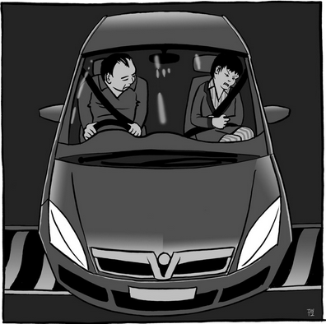

A likely ‘speed bump positive’ passenger of a car who is experiencing abdominal pain when the car is going over a speed bump. ‘Speed bump positive’ means the passenger is experiencing increased pain over normal levels while going over a speed bump. A patient that may have acute appendicitis which would be determined by histological records after surgery. This patient would answer questions about how she feels pain, leading to being classified as either ‘speed bump positive’ or ‘speed bump negative’. If she was counted as positive from histological confirmation, she would be accounted for in the primary analysis which involved finding how sensitive speed bumps are used as measuring tools, how specific they are on determining strictly acute appendicitis.